**CST8256 Web Programming Language I**

Lab 2

# Objective

1. Understate and use **Session** Object.
2. Understate and use C# Collection Classes, sort objects in a collection.

# Due Date

See Brightspace posting for the due date. To earn 5 points, you are required:

1. Complete the lab as required.
2. Zip your **website folder** into one zip file and submit the zip file to the Brightspace.
3. Demo me your lab work during the following week’s lab session.

# Requirements

Create a multi-page website in ASP.NET that allows for creating one Course, and adding student records to the course.

Use the Student and Course classes as described in the UML class diagram on the next page. This UML class diagram essentially says:

1. A course has the following properties:

* CourseNumber: A string type
* CourseName: A string type
* StudentList: A List of Student type

1. A course has the following methods:

* A constructor to initialize a course object with a specified course number and course name.
* A method to add a student object to the course
* A method to return a list of students have been added to the course
* A method to present a course object in a string.

1. Student object has the following properties:

* ID: a string type
* Name: a string type
* Grade: an integer



Your web application should two pages:

1. Default.aspx
   1. This is the default page of the website. When a user browse the website without specifying a page in the URL, the web server will send the user this page.
   2. When this page is accessed the very first time, the web application presents entry fields for collecting a course number and course name from the user:

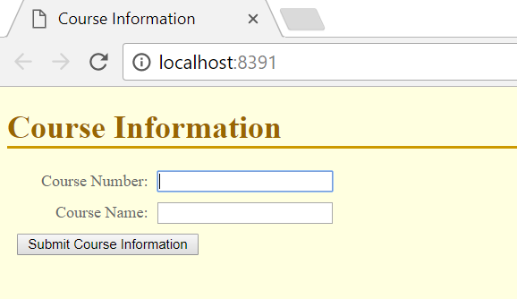

* 1. You must validate the form entries according to the following rule:
* All fields are required.
  1. Upon submission, the web application instantiates a **Course** object as in the UML class diagram and save the course object into **Session**.
  2. From now on, for any subsequent accessing to this page, the user will be redirected to the second page StudentRecords.aspx

1. StudentRecords.aspx
   1. If a user tries access this page without enter course information first, he/she will be redirected to the Default.aspx page. Otherwise this page will be displayed to gather student records.
   2. Course number and course name should be displayed in the Title bar of the page.

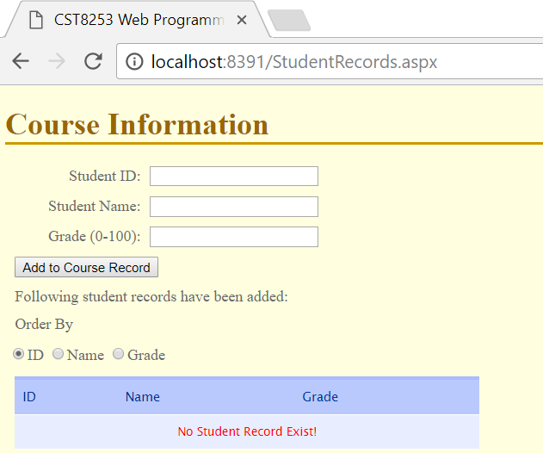

* 1. You must validate the form entries according to the following rules:
* All fields are required.
* Student name must be in the format of ***first_name last_name***

Hint: Use the following regular expression validator control:

<asp:RegularExpressionValidator ID="RegularExpValidator"

ValidationExpression="[a-zA-Z]+\s+[a-zA-Z]+" ControlToValidate="txtStudentName" CssClass="error" Display="Dynamic" ErrorMessage="Must be in first_name last_name!" runat="server"/>

* Grade must be an integer from 0 to 100 inclusive.
  1. Once the user entered all required fields and clicks **Add to Course Record** button a student object will be created and add to the student list held by the course object.
  2. The page displays a list of IDs, names and grades of the students already entered into the course. The user can continue to add more student records to the course.

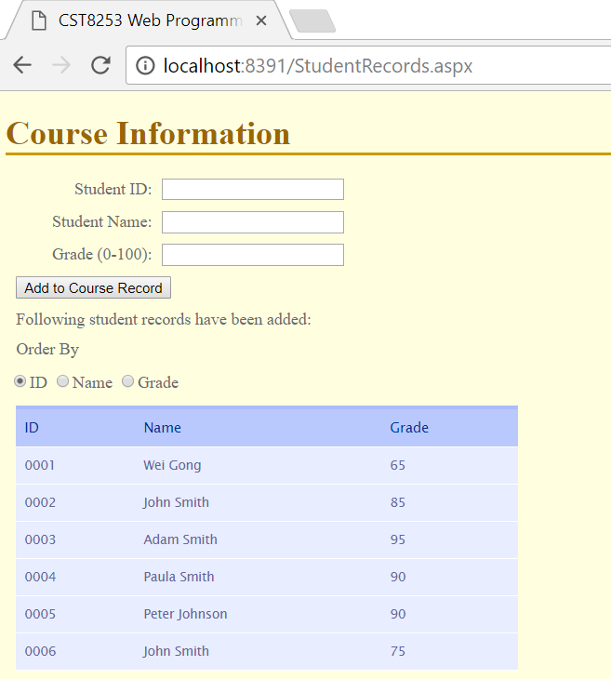

* 1. The student records in display should be in the order selected by the user via the radio button group. The students should be order as the following:
* If the user selects the **ID** radio button, the table lists the students in the ascending order of student IDs as shown above.
* If the user selects the **Name** radio button, the table lists the students in the ascending order of students’ last name.
  + For students with the same last name, it lists them in the ascending order of their first name.
  + For students with the same last name and the first name, it lists them in the ascending order of their student ID.

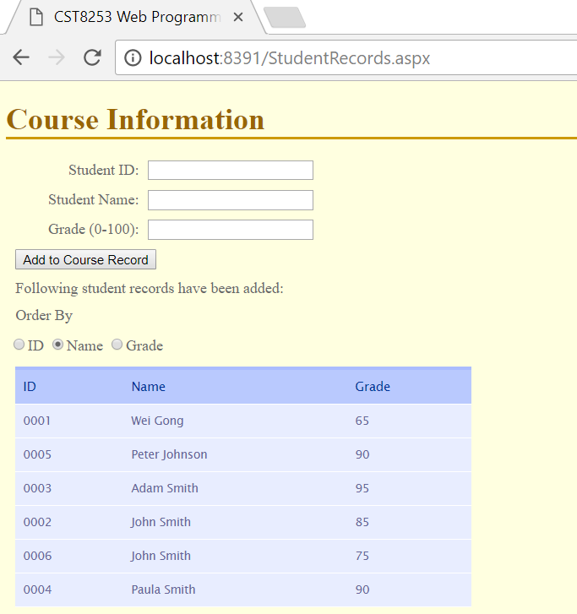

* If the user selects the Grade radio button, the table lists the students in the ascending order of students’ grade.
  + For the students with the same grade, it lists those in the order by their name as above.

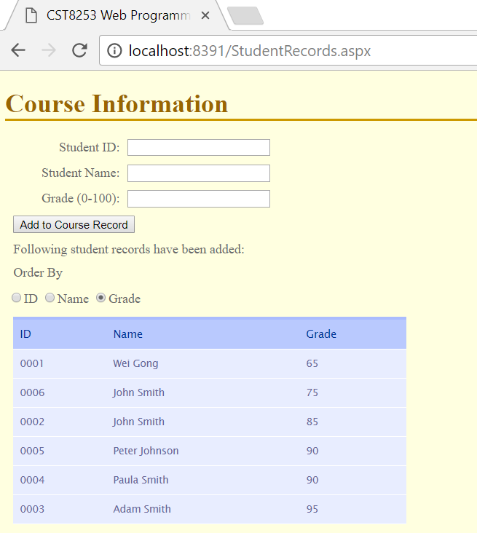

* 1. The user can change to display order anytime he/she wants by selecting from the radio button, the page should updated as soon as the radio button selection is changed.